## What is this game

This game of progression has been inspired by previously created board games called Patch-Work (reference), Hive (reference) and Tablet (Reference). A game of progression is when the players must perform a predefined set of actions to complete the game as Adams, E & Dormans explains (Adams, E & Dormans 2012).

Research was carried out followed by play troughs of these games to understand what the game mechanics are, why they are effective and how they are used. This game will use all the best mechanics from both games and combine them together.

The mechanics chosen for this game are a lock and key system; dice throwing and turn taking. The game will use the lock and key system mechanic by limiting the players available movement areas across the map until they the required amount to move out of the boundary. The dice throwing mechanic is used for the player encounter system. There will also be a turn taking mechanic where players take turns to move across the board.

## Kingdom Conqueror/ Square one position

There’s a civil war raging in the land after the king died of old age. The four male relatives to the deceased king all believe that they are the rightful heir to the throne. After several meetings they couldn’t agree who should take the throne and the war started.

The objective of the game is for the players to occupy or capture the available lands across the game board before their opponents. Players can force each other into corners of the board by capturing there lands but can be attacked by other players in the game. The winner of the game is when one player has more than 3/4 of all the available lands and therefore becomes king.

Players can also name their own scenarios that reflect the same ideas like ancient enemies from the past or fantasy races fighting for lands across the galaxy.

## First ruleset

* For up to 4 players. Red, Yellow, Blue and Green
* All the players start in there selected corners of the game board
* Each player takes a turn to place one of their coloured counters onto the board to occupy that square.
* Players can only place a counter on the board if it’s connected to their own occupied land/square.
* Players have to occupy all the lands inside their home boundary before they can advance into more access of the board.
* When two or more players come together to fight for a piece of land they all have to roll 2 six sided dice and the winner is whoever rolled the largest value of both dice combined.
* The square after the player encounter is then immune from capture for 2 turns.

## Game world

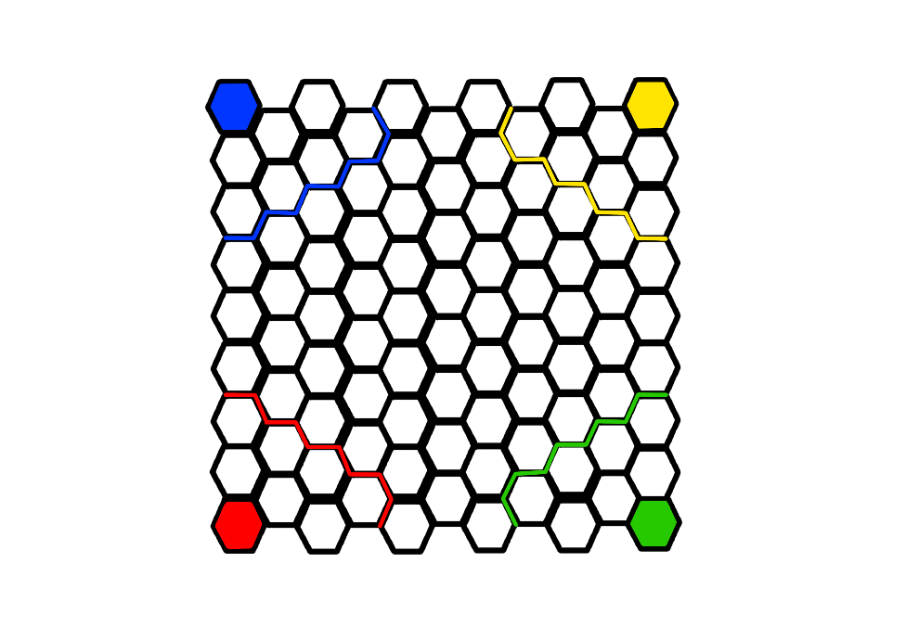

The game board shown on figure one is a 9 x 10 hexagon shaped game board.

The players start at their coloured corners of the board and 90 counters each which is the exact number of available hexagons available to occupy/capture.

The yellow, blue, green and red lines represent the lock and key system boundary where the players have to occupy before they can advance into neutral territories.

Figure 1

## Game contents

* One game board sized 31cm by 29.7cm
* 90 blue counters
* 90 yellow counters
* 90 green counters
* 90 red counters
* 2 six sided dice.

Adams, E & Dormans, J. (2012).Progression Mechanisms. In: Johnson, J & Wimpsett, T *Game Mechanics Advanced Game Design*. United States: New Riders. p247-257.